# Exercise 6

## c. Write a program to print the string in the following pattern:

### Solution:

#include<stdio.h>

#include<string.h>

void substring**(**char **[],** char**[],** int**,** int**);**

int main**()**

**{**

char str**[**100**]=**"hello"**;**

char strnew**[**100**],**strnew1**[**100**];**

int len**,**i**;**

len**=**strlen**(**str**);**

**for(**i**=**1**;**i**<**len**-**1**;**i**++)**

**{**

substring**(**str**,** strnew**,** 1**,** i**);**

printf**(**"%s\n"**,**strnew**);**

**}**

**for** **(**i **=** len**;** i**>=** 0**;**i**--)**

**{**

substring**(**str**,** strnew1**,** 1**,** i**+**1**);**

printf**(**"%s\n"**,**strnew1**);**

**}**

**return** 0**;**

**}**

void substring**(**char s**[],** char sub**[],** int p**,** int l**)** **{**

int c **=** 0**;**

**while** **(**c **<** l**)** **{**

sub**[**c**]** **=** s**[**p**+**c**-**1**];**

c**++;**

**}**

sub**[**c**]** **=** '\0'**;**

**}**

### OUTPUT:

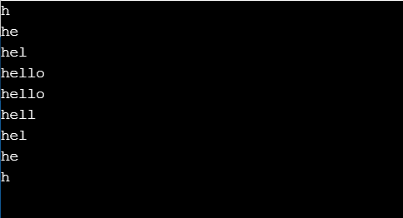

**a. Write a C program to count the number of times the given character X present in the given string.**

**Solution:**

#include <stdio.h>

int main**()** **{**

char str**[**1000**],** ch**;**

int count **=** 0**;**

printf**(**"Enter a string: "**);**

fgets**(**str**,** **sizeof(**str**),** stdin**);**

printf**(**"Enter a character to find its frequency: "**);**

scanf**(**"%c"**,** **&**ch**);**

**for** **(**int i **=** 0**;** str**[**i**]** **!=** '\0'**;** **++**i**)** **{**

**if** **(**ch **==** str**[**i**])**

**++**count**;**

**}**

printf**(**"Frequency of %c = %d"**,** ch**,** count**);**

**return** 0**;**

**}**

**OUTPUT:**

.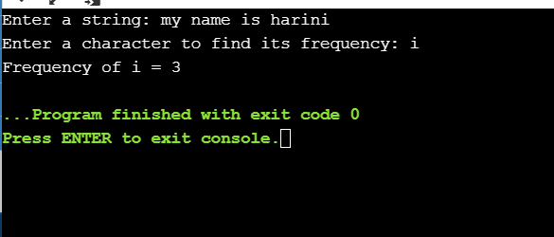

1. **Write a c program to accept the string and reverse all the characters in the given string. Check whether the reversed string is same as the original string.**

**Solution:**

#include<stdio.h>

#include <string.h>

int main**()**

**{**

char Str**[**100**],** RevStr**[**100**];**

int a**;**

int i**,** j**,** len**;**

printf**(**"\n Please Enter any String : "**);**

gets**(**Str**);**

j **=** 0**;**

len **=** strlen**(**Str**);**

**for** **(**i **=** len **-** 1**;** i **>=** 0**;** i**--)**

**{**

RevStr**[**j**++]** **=** Str**[**i**];**

**}**

RevStr**[**i**]** **=** '\0'**;**

printf**(**"\n String after Reversing = %s"**,** RevStr**);**

**return** 0**;**

**}**

Aaa

#include<stdio.h>

int main **()**

**{**

int mark**[**5**];**

int i**,** highest **=** 0**;**

int rollno**;**

**for** **(**i **=** 0**;** i **<** 5**;** i**++)**

**{**

printf **(**"\n Enter the mark of roll number : %d = "**,** i **+** 1**);**

scanf **(**"%d"**,** **&**mark**[**i**]);**

**if** **(**mark**[**i**]** **>** highest**)**

**{**

highest **=** mark**[**i**];**

rollno **=** i**;**

**}**

**}**

printf**(**"\n The highest mark scored by roll number %d : And the mark is: %d "**,**rollno **+** 1**,** highest**);**

**return 0;**

**}**

Vvvv

aaa

aaa

#include<stdio.h>

int main **()**

**{**

int mat**[**2**][**2**];**

int i**,**j**;**

**for(**i**=**0**;**i**<**2**;**i**++)**

**{**

**for(**j**=**0**;**j**<**2**;**j**++)**

**{**

printf**(**"\n enter the elements of the matrix : %d , %d "**,**i**+**1**,**j**+**1**);**

scanf**(**"%d"**,&**mat**[**i**][**j**]);**

**}**

**}**

//Print the matrix output

printf**(**"\nThe entered matrix\n"**);**

**for(**i**=**0**;**i**<**2**;**i**++)**

**{**

printf**(**"\n"**);**

**for(**j**=**0**;**j**<**2**;**j**++)**

**{**

printf**(**"%d\t"**,**mat**[**i**][**j**]);**

**}**

**}**

//Now double the diag elements

mat**[**0**][**0**]=** mat**[**0**][**0**]\***2**;**

mat**[**1**][**1**]=** mat**[**1**][**1**]\***2**;**

printf**(**"\nThe doubed matrix\n"**);**

**for(**i**=**0**;**i**<**2**;**i**++)**

**{**

printf**(**"\n"**);**

**for(**j**=**0**;**j**<**2**;**j**++)**

**{**

printf**(**"%d\t"**,**mat**[**i**][**j**]);**

**}**

**}**

**return** 0**;**

**}**

bbbb